17.79: a) normal melting point of mercury: 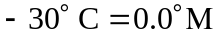
normal boiling point of mercury: 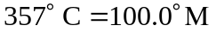
Zero on the M scale is 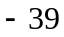 on the C scale, so to obtain 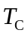 multiple 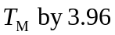 and then subtract 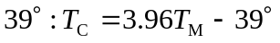
Solving for 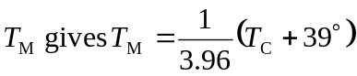
The normal boiling point of water is 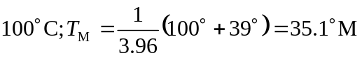
b)